Business Intelligence BIA5401 - Final Project.

Professor: Masoodhur Rahman

Neha Kataria | N01682356
Thi Khanh Linh Pham | N01696939
Muskan | N01730014
Ke Ping Lo | N01717193
Karyn Denise Pang | N01723171
Gull Qazi | N01351928

1.Abstract
The project uses airline customer reviews to identify the main topics that influence customer experiences and satisfaction. The data set contains 23,171 airline reviews with information about airline traveller types, Roots ratings, service ratings, and room reviews. The project applies NLP and topic modelling techniques to uncover common themes in customer feedback. Two topic modelling methods, LDA and non-negative matrix factorization, were compared to assess topic diversity and equality of stress test. NMF performed better overall and identified five meaningful business themes: positive cabin experience, delays and cancellation fees, customer support/refunds, seat comfort and cabin class features an airport boarding and baggage handling. These findings provide insights into the major strengths and pain points in airline customer experiences and can support improvements in service quality and customer satisfaction.

2. Introduction
Online customer reviews provide valuable unstructured feedback about airline passenger experiences, including service quality, seat comfort, delays, and baggage handling. However, manually analyzing thousands of reviews is time-consuming and makes it difficult to identify recurring themes efficiently. Topic modelling provides a scalable approach for uncovering these patterns across large collections of customer feedback.
This project analyzes 23,171 airline reviews sourced from Skytrax to identify the key themes influencing passenger experiences. Two topic modelling techniques, Latent Dirichlet Allocation (LDA) and Non-negative Matrix Factorization (NMF), were applied to the cleaned review text using the same TF-IDF representation. The models were compared using topic coherence and diversity, as well as a qualitative stress test using manually written reviews with predefined themes.
3. Business Problem
Airlines receive a large volume of customer reviews containing valuable information about passenger experiences; however, manually reviewing thousands of written comments is time-consuming and makes it difficult to identify the most common problems and areas of customer satisfaction. The business problem is therefore to identify the key themes within airline customer reviews in terminals and which areas are associated with positive or negative customer experiences. By using topic modelling, we can better understand delays, refunds, baggage handling, seating, and cabin service, allowing the airline to prioritize errors for improvement and strengthen positive aspects of the customer experience.

4. Dataset
The data used in this project is an airline review dataset containing 23,171 reviews and 20 variables. Before preprocessing, the dataset includes rich raw customer reviews along with information such as airline name, overall rating, traveller type, comfort, staff service, ground service, value for money, and recommendation status variables containing substantial missing values, particularly aircraft in-flight entertainment and Wi-Fi and connectivity used for topic modelling.

5. Data Pre-Processing
The data preprocessing was performed in several stages. First, development columns and in columns with substantial missing data were removed, including the review title and review of verified aircraft Wi-Fi connectivity in front of entertainment and food and beverages. The remaining columns were renamed to simpler names for analysis. Numerical service rating variables were converted to numerical values, and missing values were replaced using the median because the ratings are already dealt with, and some distributions were skewed; missing category values were imputed. Traveller-type seat-type replacement duplicate records were identified and removed based on the review attacks after cleaning 23,046 reviews for the text. Natural language processing techniques were applied to prepare the reviews for topic modelling. Reviews were converted to lowercase, punctuation was removed, and the text was tokenized into common English words; the remaining words were lemmatized to their base forms. Finally, the clean reviews were converted into numerical features using TF-IDF vectorization, using a maximum of 5,000 features. I removed extremely rare common words in this process, and the text was then used as the input for LDA and NMF models.
6. Methodology

The project focuses on applying Natural Language Processing (NLP) and topic modelling approaches to identify the main themes discussed in airline customer reviews. First, the data cleaning process involved removing unnecessary columns, managing missing values, and eliminating duplicate reviews. Numerical values were replaced using the median, while missing categorical values were labelled as “Unknown.” The review text was prepared for analysis by converting it to lowercase, removing punctuation and stop words, tokenizing the text and applying lemmatization.
After the preprocessing step, cleaned reviews were converted into numerical features using TF-IDF. The TF-IDF vectorizer was limited to a maximum of 5,000 features while excluding extremely rare and overly common terms. In addition, two topic modelling techniques, LDA and NMF, were applied to the same TF-IDF representation. Both models were configured to identify 5 topics, and the most important words for each topic were examined to determine the main themes in the customer reviews.
LDA and NMF performance was compared using C_v coherence score, topic diversity and a qualitative stress test. In addition, the stress test used five manually created airline reviews to examine how each model separated customer concerns across delays, baggage, cabin experience, business class, and refunds. To support interpretation, topic distributions, top-word visualizations, and word clouds were used. Overall, based on the evaluation, NMF was selected as the final model because it produced more coherent, distinct and business-interpretable topics.

7. Results
7.1 Exploratory Data Analysis
Following data cleaning and preprocessing, the dataset contained 23,046 unique airline reviews. Exploratory analysis was conducted to understand the distribution of passenger ratings, review characteristics, and common vocabulary before applying topic modelling.
The reviews had an average length of 68.17 words, with a median of 54 words, indicating substantial variation in the level of detail provided by passengers. The rating analysis showed considerable variation in passenger satisfaction, while the recommendation distribution further reflected differences in overall customer experience.
The review corpus was dominated by common airline-related terms such as flight, airline, service, staff, seat, cabin, and crew. While these terms establish the general context of the dataset, their frequency across multiple reviews also highlights the challenge of separating distinct themes. The correlation analysis of overall ratings and service dimensions further indicated that passenger satisfaction reflects multiple aspects of the airline experience rather than a single service attribute.

7.2 LDA Topic Results
LDA was fitted with five topics using the same TF-IDF representation used for NMF.LDA identified several meaningful themes, particularly cabin experience, baggage, delays, and customer-service problems. However, considerable vocabulary overlap was observed across topics, with general terms such as flight, staff, service, cabin, and crew appearing repeatedly.
Topic 4 was also highly under-represented, accounting for only 0.7% of dominant topic assignments. This suggests that the business-class and meal-service theme was not sufficiently distinct to function as a major standalone topic. Overall, LDA produced interpretable themes but showed evidence of topic redundancy and an uneven distribution of reviews.
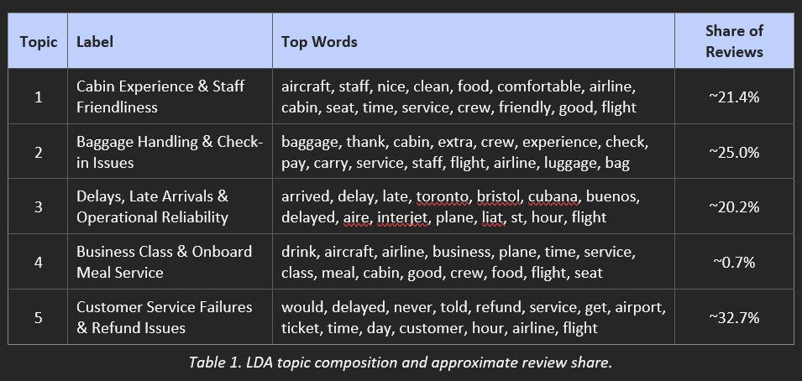
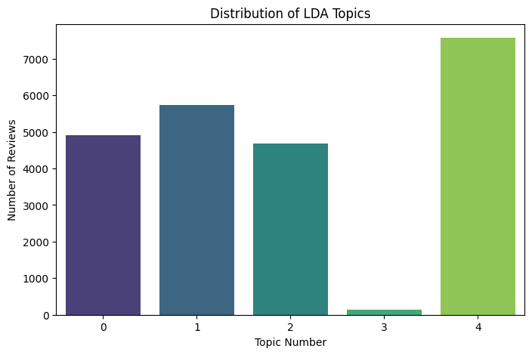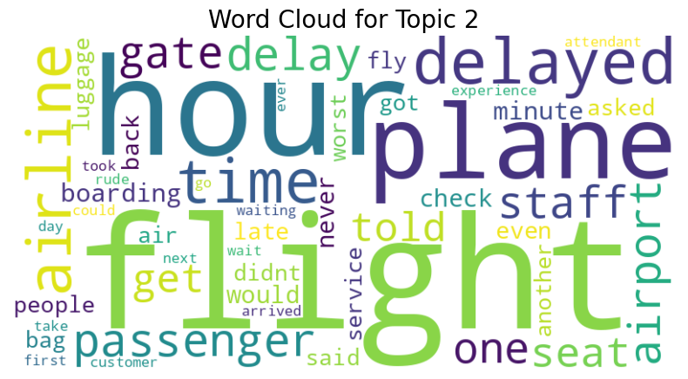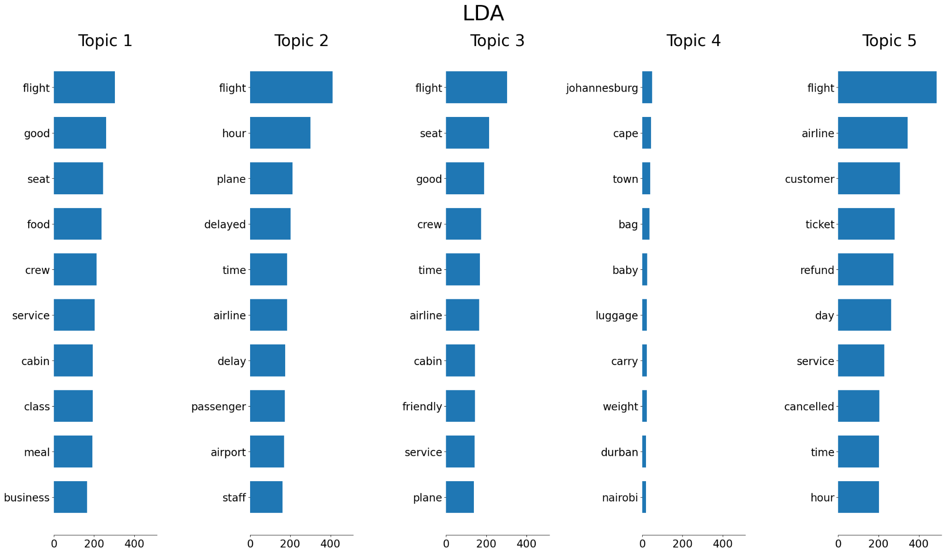

7.3 NMF Topic Results
NMF was fitted using the same five-topic configuration and TF-IDF matrix.
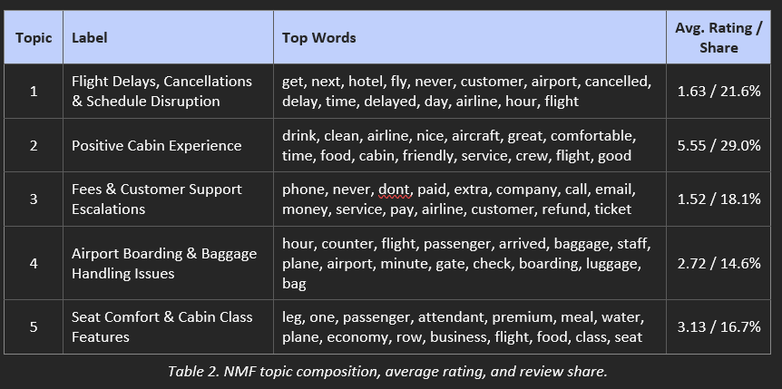
NMF produced five relatively distinct and balanced topics. Positive Cabin Experience was the largest topic, representing 29.0% of reviews and recording the highest average rating of 5.55. In contrast, Fees & Customer Support Escalations had the lowest average rating at 1.52, followed closely by Flight Delays, Cancellations & Schedule Disruption at 1.63.
The remaining topics—airport and baggage issues and seat/cabin-class features—showed moderate ratings of 2.72 and 3.13, respectively. Unlike LDA, all NMF topics represented more than 14% of the reviews, indicating a more balanced topic structure.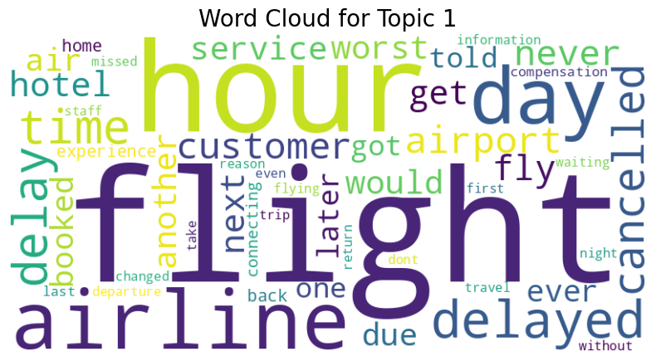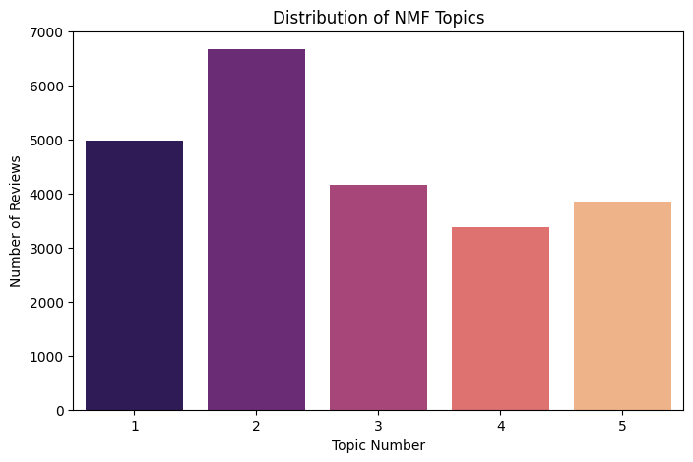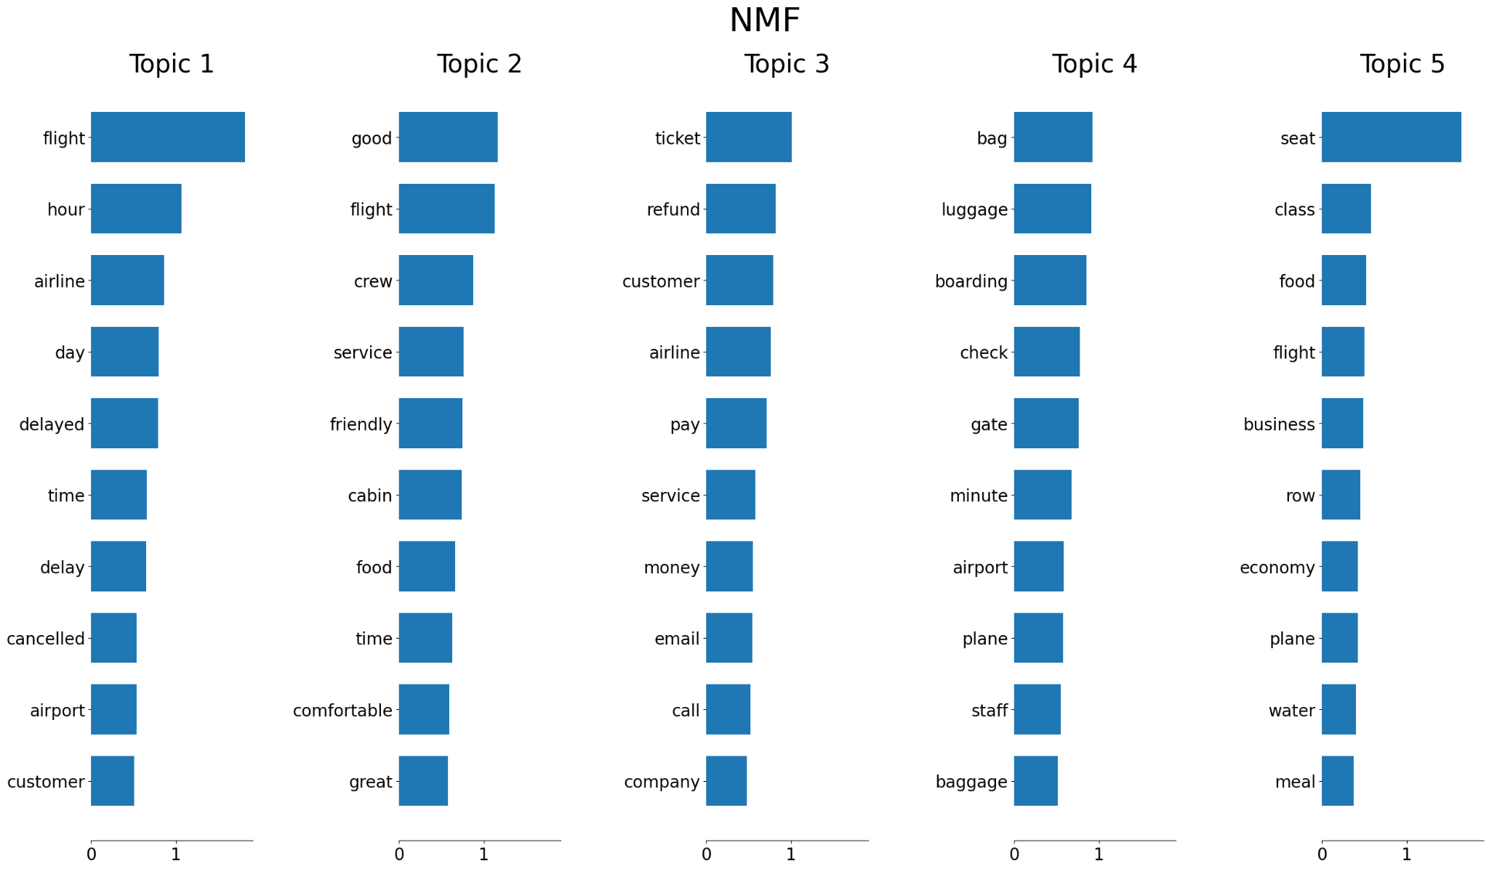
7.4 Model Evaluation and Comparison
LDA and NMF were evaluated using C_v coherence and topic diversity.NMF outperformed LDA on both evaluation metrics. Its coherence score of 0.5090 indicates stronger semantic consistency among the words within each topic, while its diversity score of 0.8133 indicates less vocabulary overlap across topics.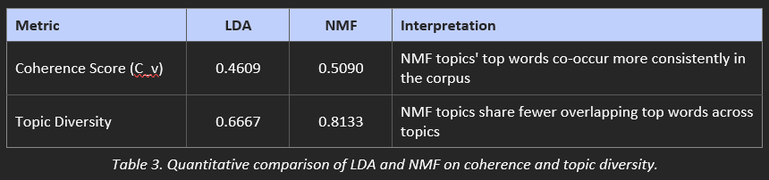
A qualitative stress test using five manually constructed reviews provided additional evidence. Both models correctly identified most intended themes; however, LDA incorrectly assigned the baggage/check-in review to its delay topic. NMF correctly separated the two themes, assigning the baggage review to its dedicated baggage topic with a 0.775 top-topic share. NMF also produced stronger assignment confidence across the test cases.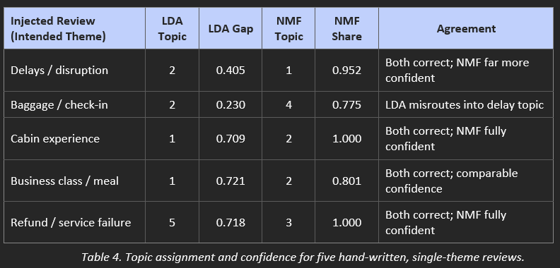

7.5 Selected Model
Overall, NMF provided the stronger topic solution for the airline review dataset. It produced more balanced topic distributions, higher coherence and diversity scores, and clearer separation of closely related themes than LDA.The NMF results also provide a useful business perspective by linking topics with average passenger ratings. The strongest negative themes were fees and customer-support issues and flight delays and cancellations, while positive cabin experience represented the most favourable area of passenger feedback.Based on these findings, the five NMF topics were selected for the subsequent business insights and recommendations.
8. Business Insights:
The NMF model identified five major themes within airline customer views. The largest topic, Positive Cabin Experience, accounts for 28.9% of reviews and has the highest average rating of 5.55. The result suggests that cabin service, cleanliness and staff interactions contribute positively to customer satisfaction. In addition, delays, cancellations, and schedule disruptions account for 21.6% of reviews, with an average rating of 1.63, while Fees and Customer Support/Refund Escalations account for 18.1% and have the lowest average rating of 1.53. Overall, these findings indicate that flight disruptions, refunds, and customer support are major areas of dissatisfaction.
Further, the remaining topics included Seat Comfort and Cabin Class Features, which represent 16.7% of reviews with an average rating of 3.13, and Airport Boarding and Baggage Handling, representing 14.7% with an average rating of 2.72. The analysis of these results suggests that airlines could improve customer satisfaction by focusing on more efficient boarding and baggage processes, better seat comfort,t and improved communication during disruptions. Overall, the findings show that while customers value cabin experience, operational reliability and customer support should be prioritized to address areas associated with the lowest ratings.
9. Limitations:
One limitation of this project is that the analysis is limited to only customer reviews, which do not represent all airline passengers. Customers with positive or negative experiences are likely to leave reviews, which can influence the topics the model identifies. In fact, the quality of topic modelling depends on the words contained in the reviews and the preprocessing steps applied. Removing certain words during the preprocessing step can result in useful context being lost.
Another limitation is the number of topics that LDA and NMF can cover. In this project, LDA and NMF identified five topics, which means the analysis cannot capture every possible issue discussed by customers. Reviews can discuss several experiences at once, so a review does not have a single dominant topic. Finally, topic interpretation requires examining the important words produced by the models and manually assigning meaningful labels. Therefore, interpretation is subjective and future analysis could test different numbers of topics or additional NLP models to improve the results.
10. Future work
Several extensions could improve the robustness and business value of this analysis. First, future research could test a wider range of topic counts and compare coherence and topic diversity to determine the optimal number of topics rather than fixing k at five. N-grams such as “flight delay,” “customer service,” and “extra baggage” could also capture meaningful phrases that individual words may overlook. Second, combining topic modelling with sentiment analysis would provide a more complete view of customer experience by identifying both what passengers discuss and whether their experiences are positive or negative. Topic prevalence could also be compared across airlines, traveller types, seat classes, and recommendation groups to identify customer-specific concerns.
Third, incorporating the temporal dimension could reveal emerging service issues and changes in customer concerns over time. More advanced approaches, such as BERTopic or transformer-based models, could also be evaluated to capture semantic relationships that traditional TF-IDF-based methods may miss. Finally, extending the analysis temporally, by tracking how topic prevalence shifts across review dates or by airline, could turn this static topic model into a monitoring tool capable of flagging emerging service issues as they develop rather than only summarizing historical feedback.
11. Conclusion
This project demonstrated how Natural Language Processing (NLP) can be used to analyze and understand large amounts of airline customer feedback in a simple and useful way. By analyzing 23,171 airline reviews and applying data cleaning, text preprocessing, TF-IDF, and LDA topic modelling, the project identified several common themes discussed by passengers. The results highlighted topics related to airline service and comfort, baggage handling, flight delays, food, and overall travel experiences. The findings show that customer reviews contain valuable information that can help airlines better understand passenger expectations and identify common problems. Instead of manually reading and analyzing thousands of reviews, NLP and topic modelling provide a faster and more efficient way to organize customer feedback into meaningful topics. This allows airlines to identify recurring issues and focus their efforts on areas that can have the greatest impact on customer satisfaction.
Overall, this project shows that NLP can support data-driven decision-making in the airline industry. The insights gained from customer reviews can help airlines improve their services, address passenger concerns, reduce common issues, and create a better overall travel experience. In the future, the analysis could be further improved by using sentiment analysis or more advanced NLP and machine learning models to identify whether customers feel positively or negatively about each topic.

